KOSHER CERTIFICATE
September, 21 2016

The following products sold by
Herrell’s Kitchen of Northampton, MA
8 Old South Street Northampton, MA 01060
Are certified kosher with the listed restrictions:

All frozen desserts when bearing the PK DAIRY symbol are certified kosher dairy.
All Baked goods when bearing the PK DAIRY symbol are certified kosher dairy.

All No-Moo® and sorbet frozen desserts when bearing the PK DE symbol
are certified kosher (using non-dairy ingredients) produced on dairy equipment.

All No-Moo®, vegan and gluten free baked goods when bearing the PK DE symbol
are certified kosher (using non-dairy ingredients) produced on dairy equipment.

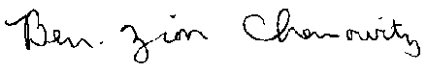
This certificate is valid until 9/21/2017
________________________
Rabbi Bentzion Chanowitz
Rabbinic Administrator

